**Assignment – 2**

|  |  |
| --- | --- |
| Assignment Date | 1 October 2022 |
| Student Name | Dhivakaran.T |
| Student Roll Number | 622119105016 |
| Maximum Marks | 2 Marks |

**Question:**

1. Create User table with user with Email, User name, Roll number, Password.
2. Perform the UPDATE,DELETE Queries with user table.
3. Connect python code to db2.
4. Create a flask app with registration page, Login page and Welcome page. By default load the registration page once the user enters all the fields store the data in database and navigate to login page authenticate user and password. If the user is show the welcome page.

**Sign up page:**

<!-- saved from url=(0069)file:///C:/Users/ELCOT/Downloads/Flask/Demo_app/templates/signup.html -->

<html><head><meta http-equiv="Content-Type" content="text/html; charset=windows-1252"></head><body>{% extends 'base.html' %}

{% block head %}

<title>Signup page</title>

<style>

.body{

padding-top: 120px; text-align: center; height: 100%

}

</style>

{% endblock%}

{% block body %}

<marquee behaviour="scroll" direction="left" bgcolor="blue">WELCOME OUR PAGE</marquee>

<div class="body">

<h2>Signup forms</h2>

<form action="file:///C:/signup">

<label for="email">Email id:</label>

<input type="text" id="email id" name="email id" class="form-control"><br><br>

<label for="password">Password:</label>

<input type="text" id="password" name="password" class="form-control"><br><br>

<input type="checkbox" id="rem" name="rem" value="rem">

<label for="rem"> Remember me?</label><br><br>

<input type="submit" value="Submit" class="btn btn-primary">

<p>Already a user? <a href="file:///C:/Users/ELCOT/Downloads/Flask/Demo_app/templates/signup.html#">LOGIN</a></p>

</form></div>

</body></html>

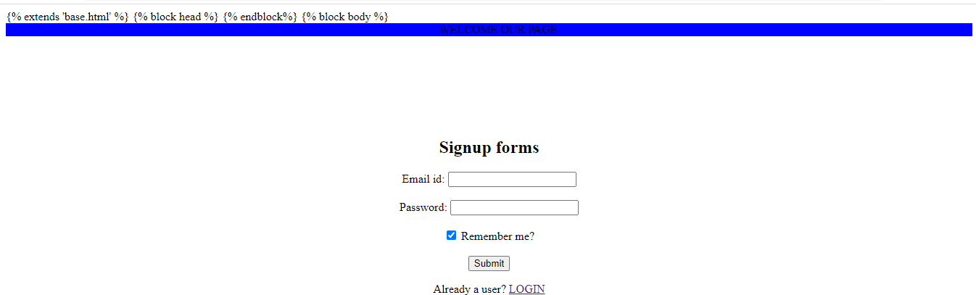

# Home page:

{% extends 'base.html' %}

{% block head %}

<title>Home page</title>

{% endblock %}

{% block body %}

<div class="p-5 mb-4 bg-light rounded-3">

<div class="container-fluid py-5">

<h1 class="display-5 fw-bold">Home Page</h1>

<p class="col-md-8 fs-4">Hii there, This is a Home page.</p>

<p class="col-md-8 fs-4">All the CSS properties are built using Bootstrap</p>

<p class="col-md-8 fs-4">Page routes are built by Jinja2 Template</p>

<p class="col-md-8 fs-4">Click on Chat on the nav bar to see the chats.</p>

<p class="col-md-8 fs-4"> Click on Sign up to enter into the Sign up form.</p>

<p class="col-md-8 fs-4">Click on Create to create a new message.</p>

<!-- <button class="btn btn-primary btn-lg" type="button">Example button</button> -->

</div>

<div>

<input type="radio" id="html" name="Gender" value="Gender">

<label for="html">MALE</label>

</div>

</div>

{% endblock %}

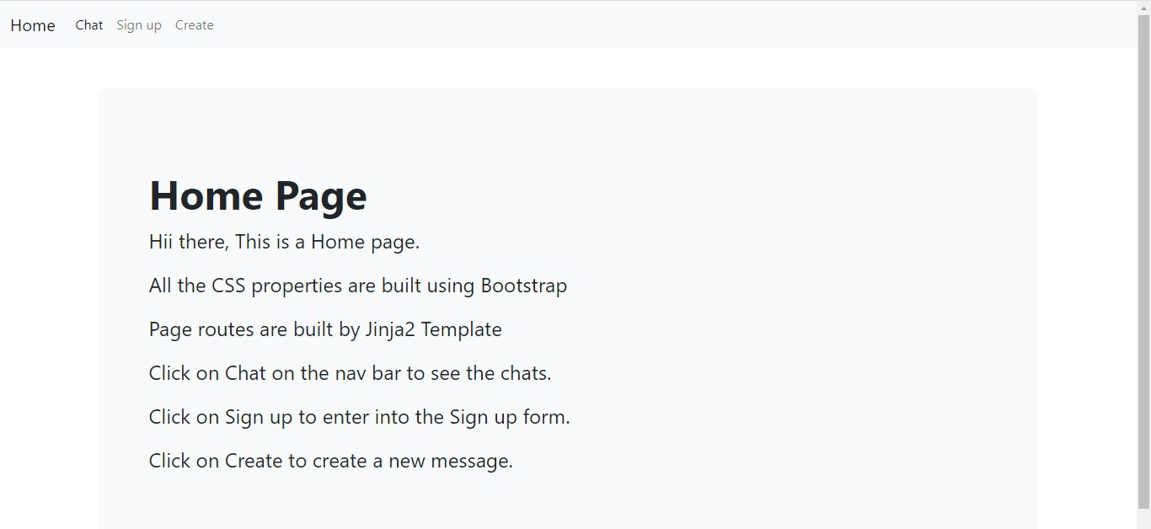

# Chat page:

{% extends 'base.html' %}

{% block body %}

<h1>{% block title %} Messages {% endblock %}</h1>

<hr>

{% for messages in messages %}

<div class="message">

<h3>{{ messages['title'] }}</h3>

<p>{{ messages['content'] }}</p>

</div>

{% endfor %}

{% endblock %}

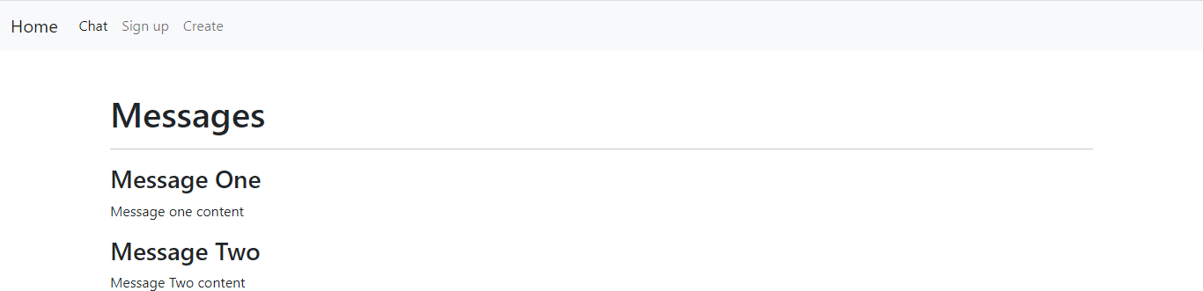

# Create page:

{% extends 'base.html' %}

{% block body %}

<h1> {% block title %} Add a New Message {% endblock %} </h1>

<form method ="post">

<label for="title">Title</label >

<br><br>

<textarea name ="content" placeholder = "Message Title" value="{{ request.form['content'] }}" class="form- control" ></textarea >

<br><br>

<label for = "content"> Message Content </label ><br>

<br>

<textarea name ="content" placeholder = "Message Content" value="{{ request.form['content'] }}" class="form-control" ></textarea >

<br><br>

<button type="Submit" class="btn btn-success">Submit</button>

</form>

{% endblock %}

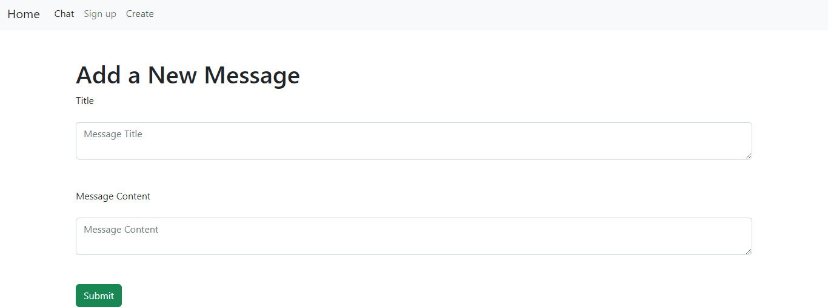

# Base page:

<!DOCTYPE html>

<html lang="en">

<head>

<meta charset="UTF-8">

<meta http-equiv="X-UA-Compatible" content="IE=edge">

<meta name="viewport" content="width=device-width, initial-scale=1.0">

<title>Document</title>

<!-- CSS only -->

<link href=["https](https://cdn.jsdelivr.net/npm/bootstrap%405.2.1/dist/css/bootstrap.min.css):[//cdn.jsdelivr.net/npm/bootstrap@5.2.1/dist/css/bootstrap.min.css"](https://cdn.jsdelivr.net/npm/bootstrap%405.2.1/dist/css/bootstrap.min.css) rel="stylesheet" integrity="sha384-iYQeCzEYFbKjA/T2uDLTpkwGzCiq6soy8tYaI1GyVh/UjpbCx/TYkiZhlZB6+fzT" crossorigin="anonymous">

<!-- JavaScript Bundle with Popper -->

<script src="[https://cdn.jsdelivr.net/npm/bootstrap@5.2.1/dist/js/bootstrap.bundle.min.js"](https://cdn.jsdelivr.net/npm/bootstrap%405.2.1/dist/js/bootstrap.bundle.min.js) integrity="sha384- u1OknCvxWvY5kfmNBILK2hRnQC3Pr17a+RTT6rIHI7NnikvbZlHgTPOOmMi466C8" crossorigin="anonymous"></script>

{% block head %} {% endblock %}

</head>

<body>

<nav class="navbar navbar-expand-lg bg-light">

<div class="container-fluid">

<a class="navbar-brand" href="{{url_for('index')}}">Home</a>

<button class="navbar-toggler" type="button" data-bs-toggle="collapse" data-bs- target="#navbarSupportedContent" aria-controls="navbarSupportedContent" aria-expanded="false" aria- label="Toggle navigation">

<span class="navbar-toggler-icon"></span>

</button>

<div class="collapse navbar-collapse" id="navbarSupportedContent">

<ul class="navbar-nav me-auto mb-2 mb-lg-0">

<li class="nav-item">

<a class="nav-link active" aria-current="page" href="{{url_for('chat')}}">Chat</a>

</li>

<li class="nav-item">

<a class="nav-link" href="{{url_for('signup')}}">Sign up</a>

</li>

<li class="nav-item">

<a class="nav-link" href="{{url_for('create')}}">Create</a>

</li>

<!-- <li class="nav-item dropdown">

<a class="nav-link dropdown-toggle" href="#" role="button" data-bs-toggle="dropdown" aria- expanded="false">

Dropdown

</a>

<ul class="dropdown-menu">

<li><a class="dropdown-item" href="#">Action</a></li>

<li><a class="dropdown-item" href="#">Another action</a></li>

<li><hr class="dropdown-divider"></li>

<li><a class="dropdown-item" href="#">Something else here</a></li>

</ul>

</li>

<li class="nav-item">

<a class="nav-link disabled">Disabled</a>

</li>

</ul>

<form class="d-flex" role="search">

<input class="form-control me-2" type="search" placeholder="Search" aria-label="Search">

<button class="btn btn-outline-success" type="submit">Search</button>

</form> -->

</div>

</div>

</nav>

<div class="container mt-5">

{% block body %} {% endblock%}

</div>

</body>

</html>

**PYTHON CODING:**

from flask import Flask, url_for,render_template,request,config,session,make_response,abort,redirect,flash; from markupsafe import escape;

app = Flask( name ); app.config['SECRET_KEY'] = 'the secret key'

# @app.route("/post/<int:post_id>") # def post(post_id):

# return f"Post {escape(post_id)} Integer"

# @app.route("/projects/") # def projects():

# return "Projects/"

@app.route("/") def index():

return render_template("index.html");

@app.route("/users/") def users():

return render_template("profile.html")

@app.route("/users/<username>") def profile(username):

return render_template("profile.html", username=username);

@app.route("/signup/") def signup():

return render_template("signup.html")

@app.errorhandler(404) def page_not_found(error):

return render_template("page_not_found.html"),404

messages=[{'title':'Message One', 'content':'Message one content' },

{'title':'Message Two', 'content':'Message Two content' },

]

@app.route("/chat") def chat():

return render_template("chat.html", messages=messages);

@app.route('/create/' , methods=('GET', 'POST')) def create():

if request.method=="POST":

title = request.form['title'] content = request.form['content']

if not title:

flash('Title is required!') elif not content:

flash('Content is required!') else:

messages.append({'title':title,'content':content})

name = "Sathishraj K."

return redirect(url_for("chat", messages=name )) return render_template("create.html")